CASE STUDY: How Do Annual Members and Casual Riders Use Cyclistic Bikes Differently?

Introduction
This case study is created for the final project of Google Data Analytics Professional Certificate Course Capstone Project. My role in this case study is a junior data analyst working in the marketing analyst team at Cyclistic, a bike-share company based in Chicago, USA. The director of marketing believes that the company’s future success depends on maximizing the number of annual memberships. Therefore, our team wants to understand how casual riders and annual members use Cyclistic bikes differently. From these insights, our team will design a new marketing strategy to convert casual riders into annual members.

Therefore, the goal of my team is to design a new marketing strategy to convert casual riders into annual members.
To do that, we need to better understand:
1. How annual members and casual riders differ
2. Why casual riders would buy a membership
3. How digital media could affect their marketing tactics.
The first question, how annual members and casual riders differ will be handled in this case study.
In order to perform this study, I used the steps of data analysis process: Ask, Prepare, Process, Analyze, Share, and Act.
Tools used in this analysis:
- Data Cleaning and Analysis: Microsoft SQL Server Management Studio
- Visualization: Tableau Public

Step 1: Ask
Background
In 2016, Cyclistic launched a successful bike-share offering. Since then the program has grown
to a fleet of 5,824 bicycles that are geotracked and locked into a network of 692 stations across
Chicago. The bikes can be unlocked from one station and returned to any other station in the
system anytime Single-ride passes, full-day passes, and annual memberships are the three adjustable price options offered by Cyclistic. Casual riders are consumers who buy single-ride or full-day passes. Annual members are clients who buy yearly memberships.
Business Task
Analyze the differences in how annual members and casual riders use cyclistic bikes. The following will be confirmed in order to do that:
- Percentage of casual rider’s vs annual members
- Frequency of rides by bike type
- Frequency of rides by month
- Number of rides by day
- Number of rides by hour
- Average ride duration by day (in minutes)
- Average ride duration by month (in minutes)

Step 2: Prepare
The Data
Motivate International Inc. has granted this license for the dataset. Anyone can utilize this publicly available data to investigate how various customer kinds are utilizing cyclistic bikes. The data is organized in monthly csv files, the most recent twelve months of data (January, 2025 – December, 2025) were used for this project.
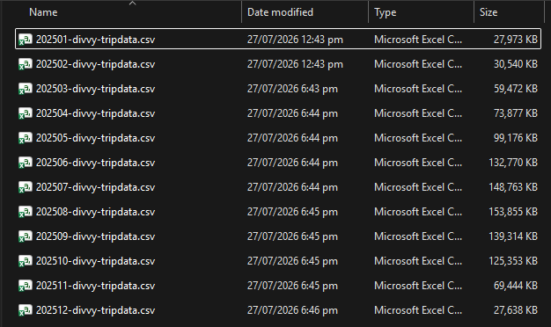
Table combined_trips was created with UNION ALL containing all tables from the 12 months
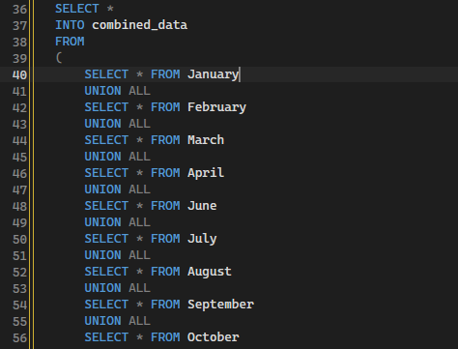

Each file has the following columns description:
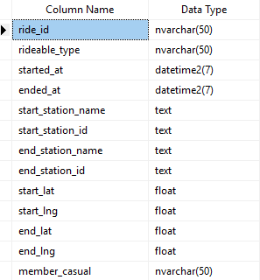

The files have the following number of rows:
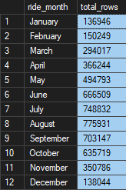

Step 3: process
Data cleaning in Microsoft SQL Server Management Studio
Each file was cleaned in Microsoft SQL Server Management Studio and then proceeded to data transformation.
- Incomplete values and missing values were checked in all the columns using IS NULL function for missing values and LEN( ) function to validate the length of incomplete values. The columns start_station_name, start_station_id, end_station_name, and end_station_id have a sizable number of missing values. Each table had those rows removed.
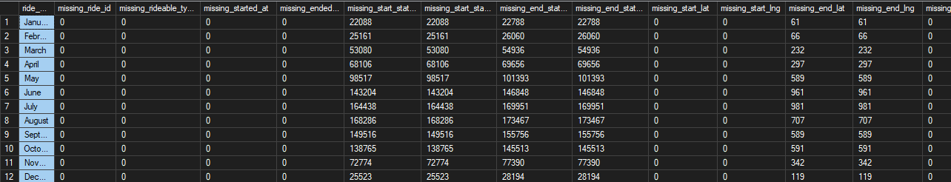

- No duplicate values were found in each file using the COUNT ( ) + GROUP BY + HAVING functions.
- The columns rideable_type and member_casual were checked and the bike type were only electric_bike and classic_bike, and the type of membership were only member and casual.
- In order to compare and analyze the volume of rides, a new table called clean_combined_trips was built using the previous table, clean_combined_trips, with new columns for month, day, hour, and duration_minutes. Records with ride durations of less than one minute or greater than 24 hours were identified as outliers and removed to improve data quality. This was achieved using a DELETE statement that filtered records where ride_length was less than 1 minute or greater than 1,440 minutes.

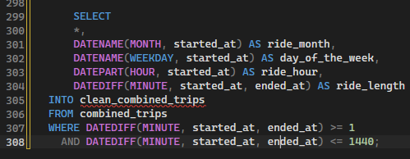

Step 4: Analyze
The following SQL queries were made in Microsoft SQL Server Management Studio in order to continue the analysis.
- Total riders by membership
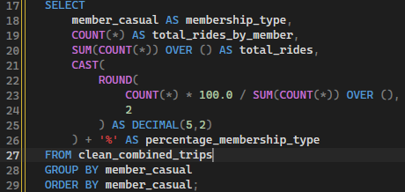
2. Frequency of rides by bike type
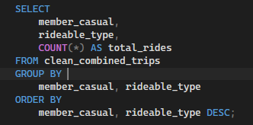

3. Ride Volume by Month
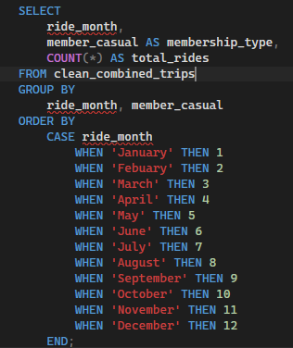

- Ride Volume by Day
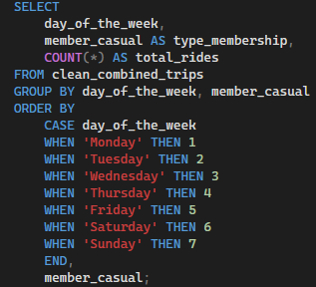

- Volume of rides by Hour
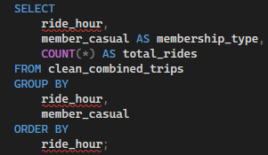

- Average ride duration by day (in minutes)
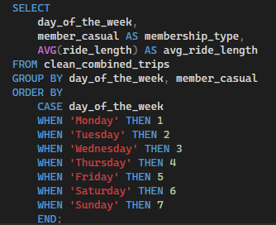

- Average ride duration by month (in minutes)
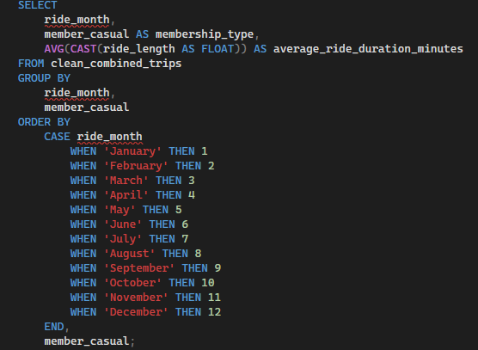

Step 5: Share
Visualizations created in Tableau
- Total riders by membership: In 2025 annual members took the most rides (64%) compare to casual riders (36%) from a total of 5,461,217 rides
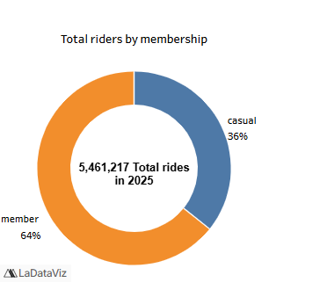

- Frequency of rides by bike type: The breakdown of bike types reveals that compared to casual riders, a greater proportion of annual members ride classic bikes. Additionally, annual members utilize electric bikes more frequently than casual riders.
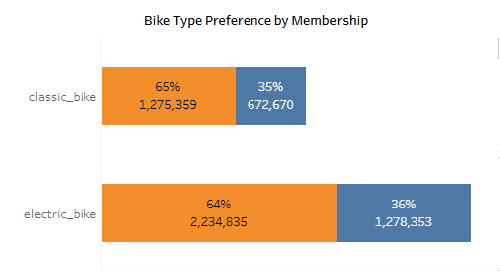

- Ride Volume by Day of the Week: This graphic shows that weekday rides are more common among annual members, whereas weekend bike rentals are more common among casual riders.
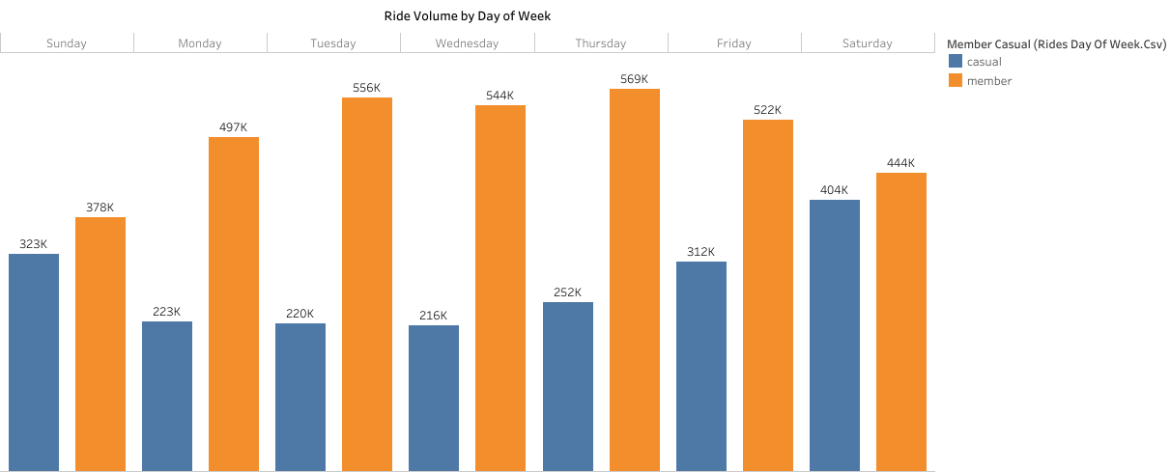

- Ride volume of the month: It is reasonable to draw the conclusion that bike rent increases on hot and sunny days, beginning in the spring (March to May) and increasing for both annual and casual members during the summer (June to August).
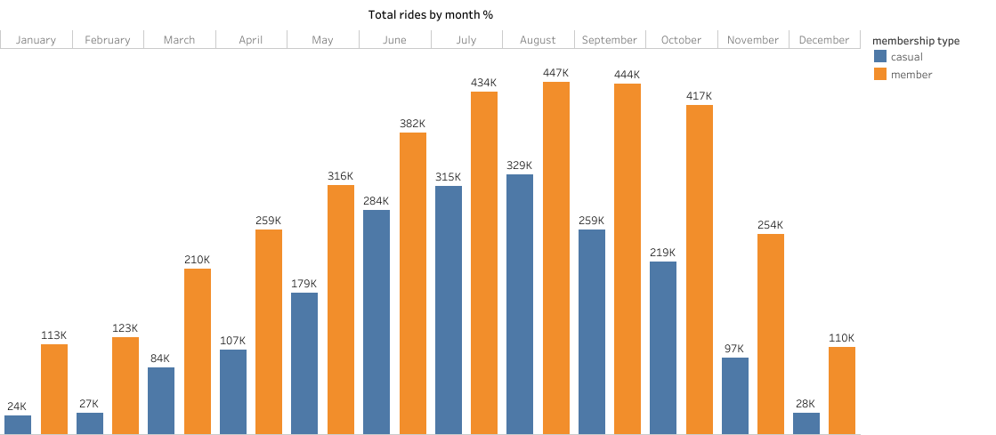

- Volume of rides by hour: This graph shows that while casual riders rent bikes gradually from 6 AM to 5 PM, annual members rent bikes at their highest rate during rush hours (morning 6 to 10 AM and afternoon 3 to 7 PM).
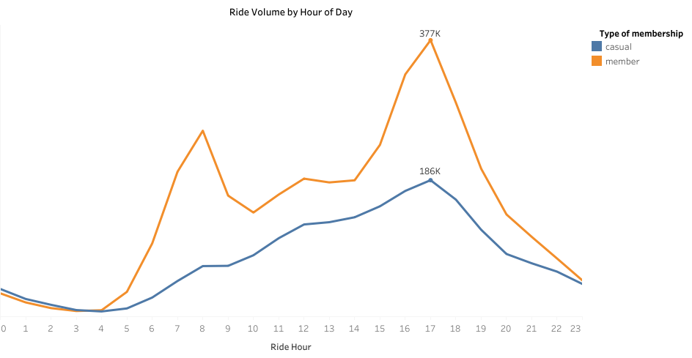

- Average ride duration by day (in minutes): The average ride duration of casual riders is significantly longer than that of annual members, with a peak on Saturday and Sunday, as shown in this graph.
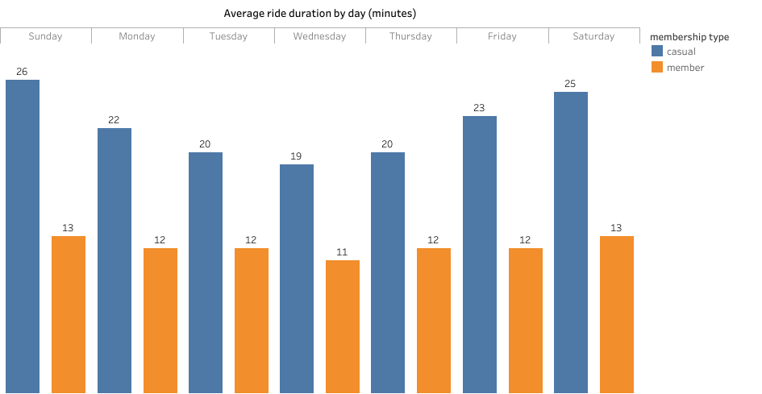

- Average ride duration by month (in minutes): This graph shows that, even when split down by month over the entire year of 2025, casual riders' average ride duration is still significantly longer than that of yearly members.
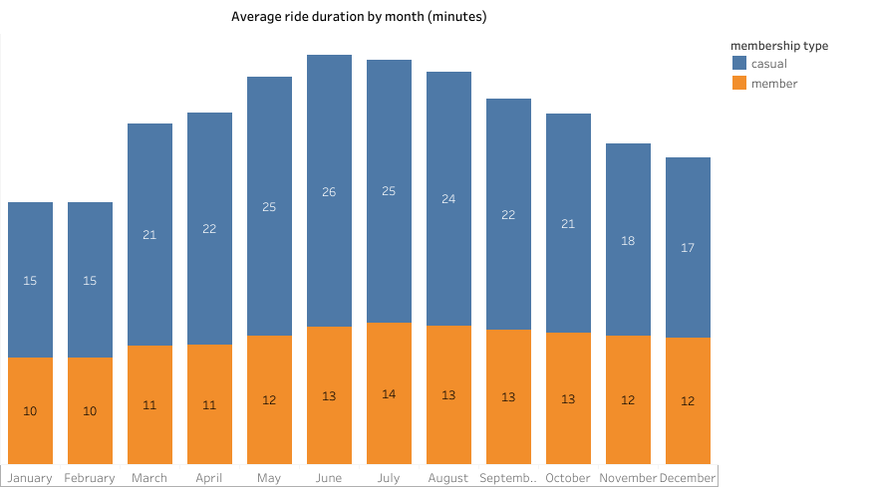

Step 6: Act
Takeaways
- Annual members completed 64% of all rides in 2025 (3.49 million rides) while casual riders accounted for 36% (1.97 million rides). This indicates that annual members are the primary users of the Cyclistic bike-sharing service.
- Casual rides averaged 20–26 minutes while annual member rides averaged 11–14 minutes, this suggests that casual riders mainly use bikes for leisure, sightseeing or recreational activities whereas members use bikes for shorter, purpose-driven trips.
- Annual members completed 2.23 million electric-bike rides compared with 1.28 million by casual riders. This indicates strong demand for electric bikes regardless of membership type.

Recommendations
- Target casual riders with membership promotions on weekends to convert casual riders into annual members.
- Launch seasonal marketing campaigns before summer (April–May) to attract riders ahead of the peak riding season.
- Highlight membership savings by showing casual riders how much they could save with an annual membership.
- Increase the availability of electric bikes during peak months and at high-demand locations to meet rider demand.
Tableau Dashboard
